| **Test Name** | Automated Operations: Pump Stays Off While Tank Drains |
| --- | --- |
| **Use Case Tested:** | Automated Operations |
| **Test Description:** | Verifies business rules/automation does nothing while the tank level is between low and high thresholds. |
| **Pre-conditions** | * Pump not running * Dashboard state of pump: not running. * ThingsBoard has not asked the pump to start running via manual operation. * Automatic control is enabled. * The “switch pump on when tank level is below” field is set to 1 metres. * The current tank level is greater than 1 metre. |
| **Post-conditions** | No change to System. Business rules have not sent a message to start the pump as the pump is in a state of not running. |
| **Notes:** | **This test can be run immediately after BPST005, the pre-conditions will be met.**  **Negative test. No change in system state should be observed.** |

|  | **TEST STEP** | **EXPECTED TEST RESULTS** |
| --- | --- | --- |
|  | Use Simulator to send tank sensor message with a level of 1.01 metres. | No changes in UI or state of pump controller other than the tank level indicator. |
|  | Wait for next status message to arrive from pump controller/simulate status message from Pump Control Simulator | No change to System. Business rules have not sent a message to start the pump as the pump is in a state of not running. |

|  |  |  |  |  |  |
| --- | --- | --- | --- | --- | --- |
| **Test Data Table** | | | | | |
|  | **1** | **2** | **3** | **4** | **5** |
| [Data field 1] | [data set 1 input value for field 1] |  |  |  |  |
| [Data field 2] | [data set 1 input value for field 2] |  |  |  |  |
| [Data field 3] | [data set 1 input value for field 3] |  |  |  |  |

**Results**

26/08/2020

Passed. The auto off message is from 2 tests ago.

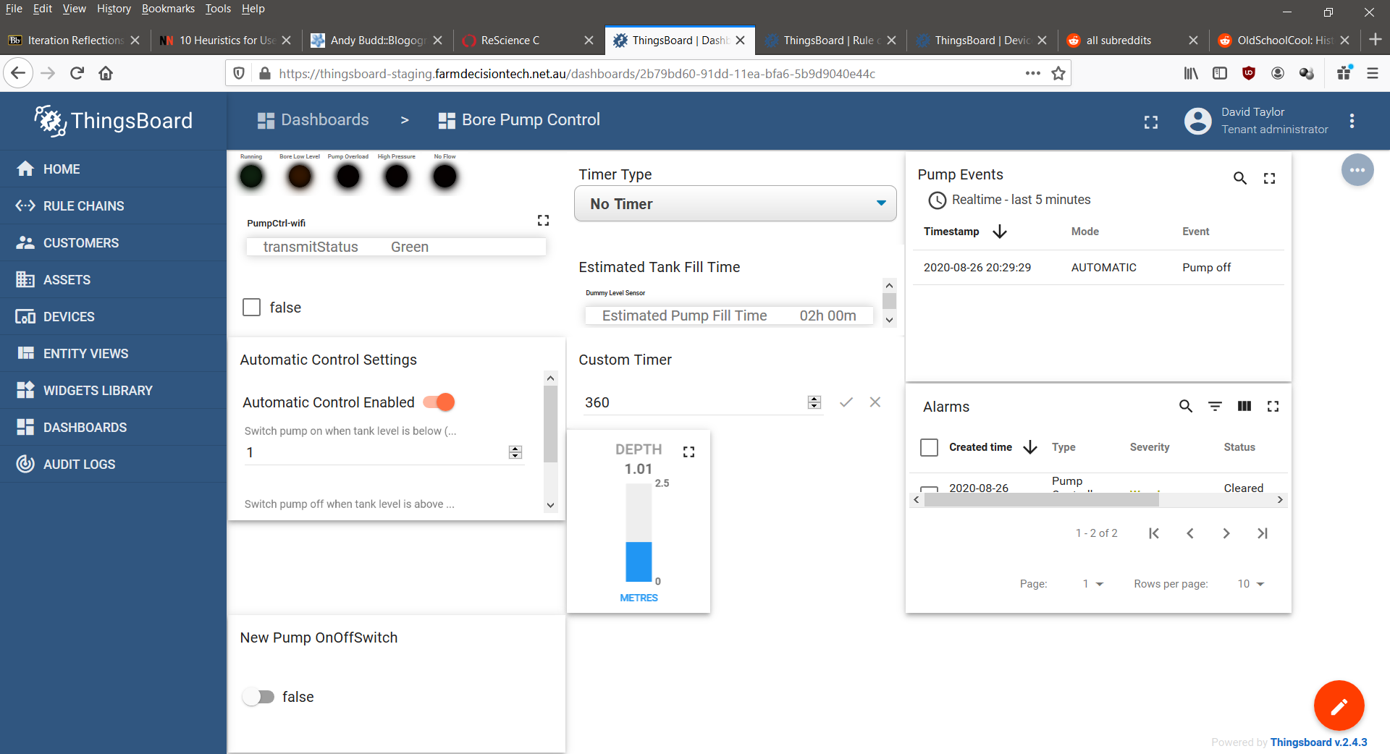

9/9/2020 – On site test at OAI.

Success.

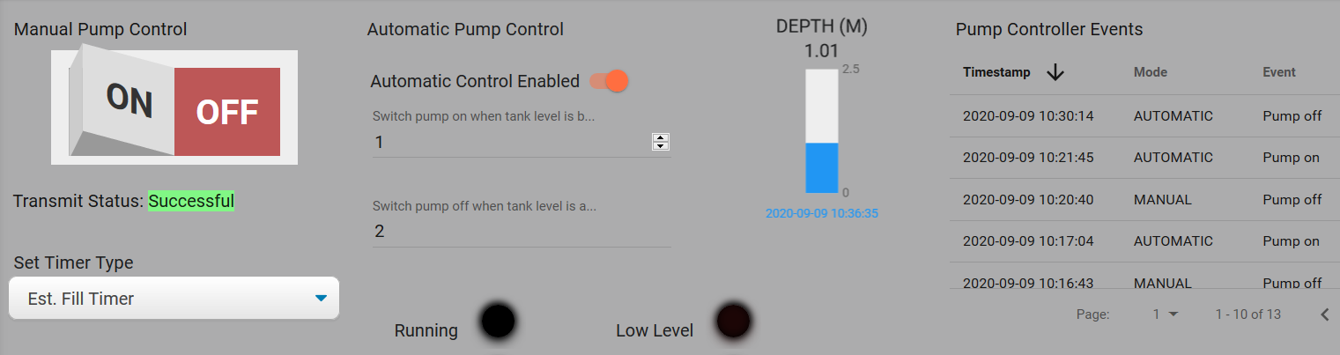

10:37:20.865 -> Send operator requested status message.

10:37:20.865 -> LoRaWAN will encode and send this message: {'pumpRunning':0,'boreLowLevel':0,'softStartFail':0,'pumpOverload':0,'controllerRestart':0,'highPressure':0,'noFlow':0}

10:37:20.865 -> Sending status byte: 00

10:37:23.005 -> EV_TXCOMPLETE (includes waiting for RX windows)